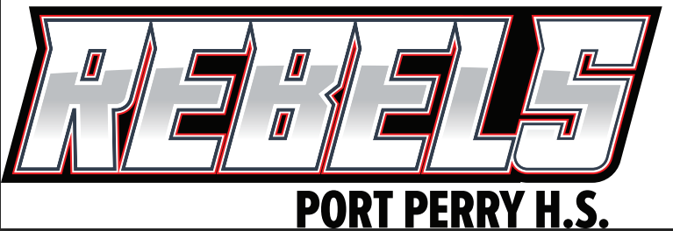
SCC Meeting
November 19, 2024
6:00 pm – 7:00pm
Administration Present: Leah Franklin (P), Lisa Wray (VP)
Topic | Notes
Call to Order | Leah Franklin
Land Acknowledgement
The Durham District School Board acknowledges that many Indigenous Nations have long-standing relationships, both historic and modern, with the territories upon which our school board and schools are located. ‎Today, this area is home to many Indigenous peoples from across Turtle Island (North America). We acknowledge that the Durham Region forms a part of the traditional and treaty territory of the Mississaugas of Scugog Island First Nation, the Mississauga Peoples, and the treaty territory of the Chippewas of Georgina Island First Nation. It is on these ancestral and treaty lands that we teach, learn, and live.

DDSB Human Rights & Equity Statement
The Durham District School Board is committed to learning and working environments that centre human rights and equity and are safe, welcoming, respectful, equitable, accessible, inclusive and free from discrimination.

Welcome and Introductions
Chair - Michelle Sheppard
Vice Chair – Val Anderson
Secretary – none (VP stand-in)
Staff Representative Report: Absent Jake Smith –
Student Representative Report: Chloe Malcolm, Ellis Fletcher
Principal Report: Overview of the Engagement team and the Parent Involvement Committee, including what we do and how we support schools and SCCs. Information on our supports, including a focus on PRO Grants and our internal teams, can help a multitude of conversations and time for networking with the Engagement team and other schools.
Midterm report cards are available on the parent portal.
Winterwonderlude
Careers Fair – New Year?
Chair Report –
Other Business/Q&A
Adjournment

